FILM FUSION – OTT PLATFORM

### A Mini Project Report submitted to

**MOHAN BABU UNIVERSITY**

### in Partial Fulfillment of the Requirements for the Award of the degree of

**BACHELOR OF TECHNOLOGY IN**

### COMPUTER SCIENCE AND ENGINEERING (DATA SCIENCE)

*Submitted by*

|  |  |
| --- | --- |
| **B. MOHAMMAD SAMEER** | **(22102A030009)** |
| **KONDEPATI SAHITHI** | **(22102A030050)** |
| **PALEPU NIKHITHA** | **(22102A030088)** |

*Under the Guidance of*

### Mr. P. Yogendra Prasad

Assistant Professor

Department of Data Science



**Department of Data Science**

**SCHOOL OF COMPUTING**

**MOHAN BABU UNIVERSITY**

Sree Sainath Nagar, Tirupati – 517 102, A.P., INDIA

2024-25

**MOHAN BABU UNIVERSITY**

Sree Sainath Nagar, Tirupati – 517 102, A.P., INDIA

2024-25

**DEPARTMENT OF DATA SCIENCE**

CERTIFICATE

This is to certify that the mini project report entitled

**“FILM FUSION – OTT PLATFORM”**

is the Bonafide work done by

|  |  |
| --- | --- |
| **B. MOHAMMAD SAMEER** | **(22102A030009)** |
| **KONDEPATI SAHITHI** | **(22102A030050)** |
| **PALEPU NIKHITHA** | **(22102A030088)** |

in the Department of **Data Science**, and submitted to Mohan Babu University, Tirupati in partial fulfillment of the requirements for the award of the degree of Bachelor of Technology in Computer Science and Engineering (Data Science) during the academic year 2024-2025. This work has been carried out under my supervision. The results of this mini project work have not been submitted to any university for the award of any degree or diploma.

***Guide: Head:***

Mr. P. Yogendra Prasad Dr. P.K. Gupta

Assistant Professor Professor & Head

Dept. of Data Science Dept. of Data Science

**INTERNAL EXAMINER EXTERNALEXAMINER**

**DEPARTMENT OF DATA SCIENCE**

**Vision**

To become a Centre of Excellence in Data Science by imparting high quality education through teaching, training and research

**Mission**

* To impart quality education in Computer Science and Engineering with specializations in Data Science by disseminating knowledge through contemporary curriculum, competent faculty and effective teaching-learning methodologies.
* Nurture research, innovation and entrepreneurial skills among students and faculty to contribute to the needs of industry and society.
* Inculcate professional attitude, ethical and social responsibilities for prospective and promising Engineering profession.
* Encourage students to engage in life-long learning by creating awareness of the contemporary developments in Computer Science and Engineering with specialization in Data Science.

**PROGRAM EDUCATIONAL OBJECTIVES**

After few years of graduation, the graduates of B. Tech. CSE(DS) will:

|  |  |
| --- | --- |
| **PEO1.** | Pursue higher studies in Computer Science, Data science or Management. |
| **PEO2.** | Become successful entrepreneurs or be employed by acquiring required skill sets in the domains of Data Science and allied areas. |
| **PEO3.** | Exhibit progression and effective adaptation to technological developments through life-long learning to address ever changing industrial requirements and follow ethical attitude in professional practice. |

**PROGRAM SPECIFIC OUTCOMES**

On successful completion of the Program, the graduates of B. Tech. CSE(DS) program will be able to:

|  |  |
| --- | --- |
| **PSO1.** | Apply appropriate data analytical techniques for building effective decision-making systems. |
| **PSO2.** | Develop intelligent systems using novel Machine Learning and Artificial Intelligence techniques. |
| **PSO3.** | Design and develop efficient software systems using modern tools, techniques, and platforms to meet societal needs. |
| **PSO4.** | Apply suitable tools and techniques to build secure distributed systems. |

**PROGRAM OUTCOMES**

On successful completion of the Program, the graduates of B.Tech. CSE (DS) Program will be able to:

|  |  |
| --- | --- |
| **PO1.** | **Engineering knowledge**: Apply the knowledge of mathematics, science, engineering fundamentals, and an engineering specialization to the solution of complex engineering problems. |
| **PO2.** | **Problem analysis**: Identify, formulate, review research literature, and analyze complex engineering problems reaching substantiated conclusions using first principles of mathematics, natural sciences, and engineering sciences. |
| **PO3.** | **Design/development of solutions**: Design solutions for complex engineering problems and design system components or processes that meet the specified needs with appropriate consideration for the public health and safety, and the cultural, societal, and environmental considerations. |
| **PO4.** | **Conduct investigations of complex problems**: Use research-based knowledge and research methods including design of experiments, analysis and interpretation of data, and synthesis of the information to provide valid conclusions. |
| **PO5.** | **Modern tool usage**: Create, select, and apply appropriate techniques, resources, and modern engineering and IT tools including prediction and modeling to complex engineering activities with an understanding of the limitations. |
| **PO6.** | **The engineer and society**: Apply reasoning informed by the contextual knowledge to assess societal, health, safety, legal and cultural issues and the consequent responsibilities relevant to the professional engineering practice. |
| **PO7.** | **Environment and sustainability**: Understand the impact of the professional engineering solutions in societal and environmental contexts, and demonstrate the knowledge of, and need for sustainable development. |
| **PO8.** | **Ethics**: Apply ethical principles and commit to professional ethics and responsibilities and norms of the engineering practice. |
| **PO9.** | **Individual and team work**: Function effectively as an individual, and as a member or leader in diverse teams, and in multidisciplinary settings. |
| **PO10.** | **Communication**: Communicate effectively on complex engineering activities with the engineering community and with society at large, such as, being able to comprehend and write effective reports and design documentation, make effective presentations, and give and receive clear instructions. |
| **PO11.** | **Project management and finance**: Demonstrate knowledge and understanding of the engineering and management principles and apply these to one’s own work, as a member and leader in a team, to manage projects and in multidisciplinary environments. |
| **PO12.** | **Life-long learning**: Recognize the need for, and have the preparation and ability to engage in independent and life-long learning in the broadest context of technological change. |

# DECLARATION

We hereby declare that this project report titled **“FILM FUSION – OTT PLATFORM”** is a genuine work carried out by us, in **B.Tech *(Computer Science and Engineering (Data Science))*** degree course of **Mohan Babu University, TIrupati** and has not been submitted to any other course or University for the award of any degree by us.

We declare that this written submission represents our ideas in our own words and where others' ideas or words have been included, we have adequately cited and referenced the original sources. We also declare that we have adhered to all principles of academic honesty and integrity and have not misrepresented or fabricated or falsified any idea / data / fact / source in our submission. We understand that any violation of the above will cause for disciplinary action by the Institute and can also evoke penal action from the sources which have thus not been properly cited or from whom proper permission has not been taken when needed.

Signature of the students 1.

2.

3.

## ABSTRACT

Movie search platforms have gained popularity for providing users with easy access to a wide range of films, especially regional cinema. These platforms offer a streamlined interface for searching and downloading movies, typically categorized by genre, language, and release date. However, they often operate in a legal grey area by hosting copyrighted content without proper licenses. Despite this, such websites thrive due to high demand for free or low-cost access to films, particularly in regions where legal streaming services may be expensive or unavailable.

In contrast, legitimate platforms like Netflix, Amazon Prime, and Disney+ offer licensed content with a focus on user experience, quality streaming, and legal distribution. These services provide secure access to a broad library of films and series, often with original content, while adhering to copyright laws. The ongoing challenge for the movie industry is balancing accessibility, affordability, and copyright enforcement, as illegal platforms continue to attract users through their extensive and often free catalogs.

This abstract explores the functionalities, user experience, and legal challenges of platforms, while also reviewing alternative movie search websites. Legitimate streaming services like Netflix, Amazon Prime Video, and Disney+ offer licensed content with high-quality streams and enhanced user interfaces, providing legal alternatives to such sites. The study also discusses the impact of piracy on the film industry and highlights the importance of promoting ethical viewing practices while ensuring affordable and accessible movie options for global audiences.

*Keywords: Online movie streaming, Movie downloading platforms, Regional content, Subscription services, Copyright infringement, Data privacy.*

## TABLE OF CONTENTS

|  |  |
| --- | --- |
| **Title** | **Page No.** |
| ABSTRACT | I |
| **CHAPTER 1: INTRODUCTION** | 1 |
| INTRODUCTION | 10 |
| STATEMENT OF THE PROBLEM | 11 |
| OBJECTIVES | 12 |
| LIMITATIONS | 12 |
| **CHAPTER 2: METHODOLOGY** | 13 |
| **CHAPTER 3: DESIGN** | 14 |
| REQUIREMENTS | 14 |
| SYSTEM DESIGN | 14 |
| TECHNOLOGIES USED | 15 |
| **CHAPTER 4: IMPLEMENTATION** | 16 |
| **CHAPTER: 5 PROPOSED SYSTEM ARCHITECTURE** | 17 |
| FLOW CHART | 18 |
| **CHAPTER 6: CODING AND RESULT** | 19 |
| CODE | 19 |
| RESULT | 46 |
| **CHAPTER 7: CONCLUSION AND FUTURE WORK** | 50 |
| CONCLUSION | 50 |
| FUTURE WORK | 50 |

**CHAPTER- 1 INTRODUCTION**

### Introduction:

This report presents a description and analysis of websites developed using advanced technologies. In recent years, Over-The-Top (OTT) platforms have transformed the way audiences consume media, delivering content directly over the internet without requiring traditional cable or satellite subscriptions. Film Fusion, an emerging OTT platform, exemplifies this shift by offering a rich library of films, documentaries, and series accessible across various devices. Built on cutting-edge web technologies, Film Fusion ensures seamless streaming, personalized recommendations, and enhanced user experience.

This document explores the underlying web technologies that power Film Fusion, enabling it to deliver high-quality content and interactive features. By leveraging advancements in HTML5, CSS3, JavaScript frameworks, and cloud-based infrastructures, Film Fusion provides an intuitive, user-centered platform that caters to diverse audience preferences. With a focus on scalability, performance, and security, this OTT service positions itself as a key player in the digital entertainment ecosystem.

At its core, Film Fusion utilizes adaptive streaming, ensuring that content quality dynamically adjusts to network conditions, offering uninterrupted playback across varying internet speeds. With a user-friendly interface built using modern JavaScript frameworks, the platform is highly responsive, supporting mobile, tablet, and desktop users alike. Furthermore, Film Fusion integrates AI-driven recommendation algorithms, tailoring content suggestions to individual preferences based on viewing history and user interactions.

By blending these advanced web technologies, Film Fusion not only meets but exceeds the expectations of today’s streaming audiences, setting a new standard for accessibility, personalization, and quality in OTT entertainment.

### Problem Statement:

In today’s fast-paced digital world, consumers demand on-the-go access to high-quality video content without interruptions, limitations, or complex interfaces. Traditional broadcasting and fragmented streaming services often fall short, unable to provide a personalized, unified, and seamless experience across all devices. For OTT platforms, this challenge is compounded by high competition, fluctuating internet speeds, diverse user preferences, and evolving content security needs.When developing this project we faced issues during testing, coding, and integration of various snippets and implementing few rules and regulations.

### Objectives:

The main objective of the Project Film Fusion aims to position itself as a leading OTT platform that offers high-quality, secure, and personalized streaming experiences while fostering a diverse and inclusive entertainment ecosystem. The objectives are:

* Provide High-Quality Streaming Experience.
* Enhance User Engagement with Personalized Content.
* Ensure Robust Content Security.
* Expand Global Reach.
* Optimize Platform Accessibility and Usability.
* Ensure Platform Scalability and Reliability.

### Limitations:

* Bandwidth and Network Dependence.
* High Infrastructure and Content Costs.
* Device Compatibility and Platform Fragmentation.

## CHAPTER – 2 METHODOLOGY

The methodology for developing Film Fusion, an OTT streaming platform, follows a structured and iterative process, ensuring high quality, scalability, and a user-centered experience. The methodology integrates agile development, user research, and continuous testing, focusing on building a responsive and secure platform. Film Fusion ensures a reliable, scalable, and user-friendly OTT platform, adapting to user needs while maintaining high performance and security. This approach enables Film Fusion to stay competitive in the dynamic OTT market by continuously evolving and optimizing the user experience. When developing this project we faced issues during testing, coding, and integration of various snippets and implementing few rules and regulations.

## CHAPTER – 3 SYSTEM DESIGN

### Requirements:

The user should have the appropriate version of windows.

* Minimum Operating System: Windows 10 (64-bit) or Windows 11.
* Internet Connection: Minimum 5 Mbps.
* Web Browser: Google Chrome (latest version), Microsoft Edge.

### System Design:

The website has a user-friendly and well-designed design to ensure a smooth browsing experience. The following sections describe the main content and structure of the site:

**HOME PAGE**: The home page promotes refer to media that is streamed directly to a user's device without the need for a cable or satellite subscription . It also provides a search bar for easy access to various sections.

**STATE LEVEL PAGES**: This website organizes state level tourism and is dedicated to all states in India. Users can navigate to the desired status page from the menu or the search function.Each state page includes a brief summary of the state's main landmarks, their cultural significance, and a list of state attractions.

**PAGES**: Every travel destination in the state has its own dedicated page. These pages provide detailed information about the location, including history, scenic spots, attractions, local cuisine, transportation options, and travel advice. Provide beautiful graphics and interactive graphics to enhance user experience.

**RESPONSIVE DESIGN**: The website is designed to be responsive, responsive, and usable on a variety of devices, including desktop computers, tablets, and mobile phones. The layouts fit seamlessly into different parts of the screen, increasing accessibility as users move around.

### Technologies used:

The website is built using front-end technologies to create an engaging and dynamic user interface. The key technologies employed in the development of this website are:

**HTML5**: The website structure and content are created using HTML5, ensuring semantic markup and proper organization of information.

**CSS3**: CSS3 is used for styling and visual presentation of the website, including layout design, color schemes, typography, and responsive elements.

**JAVASCRIPT**: JavaScript is utilized to implement interactive features such as search functionality, user reviews, interactive maps, and dynamic content loading

## CHAPTER - 4 IMPLEMENTATION

The implementation of the project consists of several stages to create a website the Film Fusion OTT platform requires coordinating various technologies, libraries, and services to develop a robust and scalable solution. The implementation stages, from frontend and backend development to video processing and Devlops.

First, a good needs analysis was done to understand the purpose of the project, its target audience and the work that needs to be done. After the content is collected, the wireframing and design phase of the website began. This includes clear layouts and designs to provide a clear user experience, design for consistency across devices, and creating beautiful connections.

After this front-end development phase, which uses HTML5, CSS3, JavaScript, and php to implement the website's visual content, interactive features, and user interface. The collected data was organized in the database. The database will create a relationship between information organizations to enable the retrieval and display of information on the website. We performed quality testing and quality assurance to ensure website functionality, functionality and browser compatibility.

## CHAPTER-5

**PROPOSED SYSTEM ARCHITECTURE**

The system architecture for the website To design a scalable, secure, and high-performance OTT platform like Film Fusion, the architecture should focus on modular components that handle specific functions effectively. This proposed architecture breaks down the system into several interconnected layers, leveraging cloud infrastructure and web technologies to deliver high-quality, secure content to users around the world. At the presentation layer, the user interface is developed using technologies like HTML, CSS, and JavaScript. The application layer handles the business logic and user requests, The data access layer interacts with the underlying database, performing data retrieval and storage using technologies like MySQL. The proposed system architecture is designed to be modular, scalable, and maintainable, allowing for future enhancements and the addition of new features.

### 5.1 Flow Chart:

### 

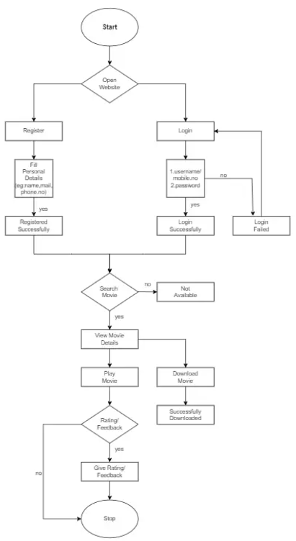

**Fig. demonstration of the website**

## CHAPTER-6

**CODING ANALYSIS AND RESULTS**

### Code:

1. **Login Page / Registration page:**

<!DOCTYPE html>

<html lang="en">

<head>

<meta charset="UTF-8">

<meta name="viewport" content="width=device-width, initial-scale=1.0">

<title>FILM FUSION </title>

<link rel="stylesheet" href="style.css">

<style>

body {

font-family: 'Arial', sans-serif;

background: #141414;

color: #fff;

display: flex;

justify-content: center;

align-items: center;

height: 100vh;

margin: 0;

}

.container {

background: #1f1f1f;

padding: 20px;

border-radius: 10px;

box-shadow: 0 4px 8px rgba(0, 0, 0, 0.3);

width: 400px;

text-align: center;

}

.logo h1 {

color: #ff5722;

margin: 0 0 20px 0;

}

.form-container {

background: #222;

padding: 20px;

border-radius: 8px;

}

.form-toggle {

display: flex;

justify-content: center;

margin-bottom: 15px;

}

.form-toggle button {

background: #333;

color: #fff;

border: none;

padding: 10px 20px;

margin: 0 5px;

cursor: pointer;

border-radius: 5px;

}

.form-toggle button:hover {

background: #ff5722;

}

.form {

display: flex;

flex-direction: column;

}

.form input {

padding: 10px;

margin: 10px 0;

border-radius: 5px;

border: 1px solid #555;

background: #333;

color: #fff;

}

button {

background: #ff5722;

color: #fff;

border: none;

padding: 10px;

border-radius: 5px;

cursor: pointer;

font-weight: bold;

}

button:hover {

background: #e64a19;

}

p {

margin: 10px 0 0;

}

p a {

color: #ff5722;

text-decoration: none;

}

p a:hover {

text-decoration: underline;

}

</style>

</head>

<body>

<div class="container">

<div class="logo">

<h1>FILM FUSION</h1>

</div>

<div class="form-container">

<div class="form-toggle">

<button onclick="document.getElementById('login-form').style.display='block';

document.getElementById('register-form').style.display='none'">Login</button>

<button onclick="document.getElementById('register-form').style.display='block';

document.getElementById('login-form').style.display='none'">Register</button>

</div>

<form id="login-form" class="form" action="login success.html" method="get"

style="display: block;">

<h2>Login</h2>

<input type="email" name="email" placeholder="Email" required>

<input type="password" name="password" placeholder="Password" required>

<button type="submit">Login</button>

<p>Don't have an account? <a href="#" onclick="document.getElementById('register-

form').style.display='block'; document.getElementById('login-form').style.display='none'">Register

here</a></p>

</form>

<form id="register-form" class="form" action="regsuccess.html" method="get"

style="display: none;">

<h2>Register</h2>

<input type="text" name="username" placeholder="Username" required>

<input type="email" name="email" placeholder="Email" required>

<input type="password" name="password" placeholder="Password" required>

<input type="password" name="confirm-password" placeholder="Confirm Password"

required>

<button type="submit">Register</button>

<p>Already have an account? <a href="#" onclick="document.getElementById('login-

form').style.display='block'; document.getElementById('register-form').style.display='none'">Login

here</a></p>

</form>

</div>

</body>

</html></BODY>

### Home Page:

<!DOCTYPE html>

<html lang="en">

<head>

<meta charset="UTF-8">

<meta name="viewport" content="width=device-width, initial-scale=1.0">

<title>Film Fusion</title>

<!--------Box-icons------------>

<link href='https://unpkg.com/boxicons@2.1.4/css/boxicons.min.css' rel='stylesheet'>

<!----Link Swiper--------------------->

<link rel="stylesheet" href="swiper-bundle.min.css">

<!-------------link-css--------------->

<link rel="stylesheet" href="style.css">

<!---------shortcut icon-------------->

</head>

<body>

<header>

<!--nav-->

<div class="nav container">

<!---logo-->

<a href="FF.html" class="logo">

Film <span>Fusion</span>

</a>

<!------logout btn----->

<!-------Search box-->

<div class="search-box">

<input type="search" name="" id="search-input" placeholder="Search movie">

<i class='bx bx-search'></i>

</div>

<!--------logout-->

<div class="logout">

<a href="loginpage.html" class="next-btn">Logout</a>

</div>

<!-----user---------->

<a href="#" class="user">

<!----------User IMG----->

<img src="logo.png" alt="FF" class="user-img">

</a>

<!-------navbar------>

<div class="navbar">

<a href="#home" class="nav-link nav-active">

<i class='bx bx-home' ></i>

<span class="nav-link-title">Home</span>

</a>

<a href="#popular " class="nav-link">

<i class='bx bxs-hot' ></i>

<span class="nav-link-title">Trending</span>

</a>

<a href="#movies" class="nav-link">

<i class='bx bx-compass' ></i>

<span class="nav-link-title">Explore</span>

</a>

<a href="nextpage.html" class="nav-link">

<i class='bx bx-tv' ></i>

<span class="nav-link-title">Next Page</span>

</a>

<a href="#Contact" class="nav-link">

<i class='bx bxs-contact' ></i>

<span class="nav-link-title">Contact</span>

</a>

</div>

</div>

</header>

<!---home-->

<section class="home container" id="home" >

<!-------home img----->

<img src="wp5497939-avengers-fortnite-wallpapers.jpg" alt="" class="home-img">

<!--home text---->

<div class="home-text">

<h1 class="home-title">AVENGERS <br>END GAME</h1>

<p>Released on 2019</p>

<a href="endgame.html" class="watch-btn">

<i class='bx bx-right-arrow'></i>

<span>Watch Movie Now </span>

</a>

</div>

</section>

<!-------popular container start----->

<section class="popular container " id="popular">

<!----Heading----->

<div class="heading">

<h2 class="heading-title">Popular </h2>

<!----Swiper Buttons-->

<div class="swiper-btn">

<div class="swiper-button-prev"></div>

<div class="swiper-button-next"></div>

</div>

</div>

<!---content---->

<div class="popular-content swiper">

<div class="swiper-wrapper">

<!-------Movies Box 1-->

<div class="swiper-slide">

<div class="movie-box">

<img src="dpw.jpg" alt="" class="movie-box-img">

<div class="box-text">

<h2 class="movie-title"></h2>

<span class="movie-type"></span>

<a href="dpwpage.html" class="watch-btn play-btn">

<i class='bx bx-right-arrow'></i>

</a>

</div>

</div>

</div>

<!-------Movies Box 2-->

<div class="swiper-slide">

<div class="movie-box">

<img src="civil-war.jpg" alt="" class="movie-box-img">

<div class="box-text">

<h2 class="movie-title"></h2>

<span class="movie-type"></span>

<a href="civilwar.html" class="watch-btn play-btn">

<i class='bx bx-right-arrow'></i>

</a>

</div>

</div>

</div>

<!-------Movies Box 3-->

<div class="swiper-slide">

<div class="movie-box">

<img src="nwh.jpg" alt="" class="movie-box-img">

<div class="box-text">

<h2 class="movie-title"></h2>

<span class="movie-type"></span>

<a href="nwh.html" class="watch-btn play-btn">

<i class='bx bx-right-arrow'></i>

</a>

</div>

</div>

</div>

<!-------Movies Box 4-->

<div class="swiper-slide">

<div class="movie-box">

<img src="ds.jpg" alt="" class="movie-box-img">

<div class="box-text">

<h2 class="movie-title"></h2>

<span class="movie-type"></span>

<a href="strange.html" class="watch-btn play-btn">

<i class='bx bx-right-arrow'></i>

</a>

</div>

</div>

</div>

<!-------Movies Box 5-->

<div class="swiper-slide">

<div class="movie-box">

<img src="CA.jpg" alt="" class="movie-box-img">

<div class="box-text">

<h2 class="movie-title"></h2>

<span class="movie-type"></span>

<a href="captain.html" class="watch-btn play-btn">

<i class='bx bx-right-arrow'></i>

</a>

</div>

</div>

</div>

<!-------Movies Box 6-->

<div class="swiper-slide">

<div class="movie-box">

<img src="venom1.jpg" alt="" class="movie-box-img">

<div class="box-text">

<h2 class="movie-title"></h2>

<span class="movie-type"></span>

<a href="venom.html" class="watch-btn play-btn">

<i class='bx bx-right-arrow'></i>

</a>

</div>

</div>

</div>

<!-------Movies Box 7-->

<div class="swiper-slide">

<div class="movie-box">

<img src="avengers2012.jpg" alt="" class="movie-box-img">

<div class="box-text">

<h2 class="movie-title"></h2>

<span class="movie-type"></span>

<a href="theavengers2012.html" class="watch-btn play-btn">

<i class='bx bx-right-arrow'></i>

</a>

</div>

</div>

</div>

<!-------Movies Box 8-->

<div class="swiper-slide">

<div class="movie-box">

<img src="IW.jpg" alt="" class="movie-box-img">

<div class="box-text">

<h2 class="movie-title"></h2>

<span class="movie-type"></span>

<a href="aiw.html" class="watch-btn play-btn">

<i class='bx bx-right-arrow'></i>

</a>

</div>

</div>

</div>

<!-------Movies Box 9-->

<div class="swiper-slide">

<div class="movie-box">

<img src="dp1.jpg" alt="" class="movie-box-img">

<div class="box-text">

<h2 class="movie-title"></h2>

<span class="movie-type"></span>

<a href="deadpool.html" class="watch-btn play-btn">

<i class='bx bx-right-arrow'></i>

</a>

</div>

</div>

</div>

<!-------Movies Box 10-->

<div class="swiper-slide">

<div class="movie-box">

<img src="iron-man-3.jpg" alt="" class="movie-box-img">

<div class="box-text">

<h2 class="movie-title"></h2>

<span class="movie-type"></span>

<a href="Ironman3.html" class="watch-btn play-btn">

<i class='bx bx-right-arrow'></i>

</a>

</div>

</div>

</div>

<!-------Movies Box 11-->

<div class="swiper-slide">

<div class="movie-box">

<img src="Ageofultron.jpg" alt="" class="movie-box-img">

<div class="box-text">

<h2 class="movie-title"></h2>

<span class="movie-type"></span>

<a href="aou.html" class="watch-btn play-btn">

<i class='bx bx-right-arrow'></i>

</a>

</div>

</div>

</div>

<!-------Movies Box 12-->

<div class="swiper-slide">

<div class="movie-box">

<img src="pirates2003.jpg" alt="" class="movie-box-img">

<div class="box-text">

<h2 class="movie-title"></h2>

<span class="movie-type"></span>

<a href="Pirates.html" class="watch-btn play-btn">

<i class='bx bx-right-arrow'></i>

</a>

</div>

</div>

</div>

</div>

</div>

</section>

<!---popular section end---->

<!---Movies Section Start---->

<section class="movies container" id="movies">

<!---Heading----------->

<div class="heading">

<h2 class="heading-title">Telugu Movies</h2>

</div>

<!----------Movies Conetent-->

<div class="movies-content">

<div class="movie-box">

<img src="devara.jpg" alt="" class="movie-box-img">

<div class="box-text">

<h2 class="movie-title"></h2>

<span class="movie-type"></span>

<a href="devara.html" class="watch-btn play-btn">

<i class='bx bx-right-arrow'></i>

</a>

</div>

</div>

<!-------Movies Box 2-->

<div class="movie-box">

<img src="Kalki_2898_AD.jpg" alt="" class="movie-box-img">

<div class="box-text">

<h2 class="movie-title"></h2>

<span class="movie-type"></span>

<a href="KALKI2898.HTML" class="watch-btn play-btn">

<i class='bx bx-right-arrow'></i>

</a>

</div>

</div>

<!-------Movies Box 3-->

<div class="movie-box">

<img src="Bheemla_Nayak.jpg" alt="" class="movie-box-img">

<div class="box-text">

<h2 class="movie-title"></h2>

<span class="movie-type"></span>

<a href="bheemla.html" class="watch-btn play-btn">

<i class='bx bx-right-arrow'></i>

</a>

</div>

</div>

<!-------Movies Box 4-->

<div class="movie-box">

<img src="pushpa.jpg" alt="" class="movie-box-img">

<div class="box-text">

<h2 class="movie-title"></h2>

<span class="movie-type"></span>

<a href="PUSHPA.HTML" class="watch-btn play-btn">

<i class='bx bx-right-arrow'></i>

</a>

</div>

</div>

<!-------Movies Box 5-->

<div class="movie-box">

<img src="Eagle.jpg" alt="" class="movie-box-img">

<div class="box-text">

<h2 class="movie-title"></h2>

<span class="movie-type"></span>

<a href="eagle.html" class="watch-btn play-btn">

<i class='bx bx-right-arrow'></i>

</a>

</div>

</div>

<!-------Movies Box 6-->

<div class="movie-box">

<img src="ene.jpg" alt="" class="movie-box-img">

<div class="box-text">

<h2 class="movie-title"></h2>

<span class="movie-type"></span>

<a href="ENE.HTML" class="watch-btn play-btn">

<i class='bx bx-right-arrow'></i>

</a>

</div>

</div>

<!-------Movies Box 7-->

<div class="movie-box">

<img src="gk.jpg" alt="" class="movie-box-img">

<div class="box-text">

<h2 class="movie-title"></h2>

<span class="movie-type"></span>

<a href="GK.HTML" class="watch-btn play-btn">

<i class='bx bx-right-arrow'></i>

</a>

</div>

</div>

<!-------Movies Box 8-->

<div class="movie-box">

<img src="rangasthalam.jpg" alt="" class="movie-box-img">

<div class="box-text">

<h2 class="movie-title"></h2>

<span class="movie-type"></span>

<a href="RANGASTHALAM.HTML" class="watch-btn play-btn">

<i class='bx bx-right-arrow'></i>

</a>

</div>

</div>

</div>

</div>

</section>

<!---Movies Section End---->

<!---Movies Section End---->

<section class="movies container" id="Contact">

<!---Heading----------->

<div class="heading">

<h2 class="heading-title">Contact</h2>

<p>filmfusion@gmail.com</p>

</div>

</section>

<!----Feedback----->

<div class="next-page">

<a href="feedback.html" class="next-btn">Feedback</a>

</div>

<!----copyright----------->

<div class="copyright">

<p>&#169; All Rights Reserevd</p>

</div?

<!----------Link swiper JS-->

<script src="swiper-bundle.min.js"></script>

<script>

var swiper = new Swiper(".popular-content", {

slidesPerView:1,

spaceBetween: 10,

autoplay: {

delay: 5500,

disableOnInter: false,

},

pagination: {

el: ".swiper-pagination",

clickable: true,

},

navigation: {

nextEl: ".swiper-button-next",

prevEl: ".swiper-button-prev",

},

breakpoints:{

280:{

slidesPerView:1,

spaceBetween: 10,

},

320:{

slidesPerView:2,

spaceBetween: 10,

},

510:{

slidesPerView:2,

spaceBetween: 10,

},

758:{

slidesPerView:3,

spaceBetween: 15,

},

900:{

slidesPerView:4,

spaceBetween: 20,

},

},

});

</script>

</body>

</html>

### Avengers Endgame movie Page:

<!DOCTYPE html>

<html lang="en">

<head>

<meta charset="UTF-8">

<meta name="viewport" content="width=device-width, initial-scale=1.0">

<title>ENDGAME</title>

<link href='https://unpkg.com/boxicons@2.1.4/css/boxicons.min.css' rel='stylesheet'>

<link rel="stylesheet" href="style.css">

</head>

<body>

<header>

<!--nav-->

<div class="nav container">

<!---logo-->

<a href="" class="logo">

Film <span>Fusion</span>

</a>

<!-------Search box-->

<div class="search-box">

<input type="search" name="" id="search-input" placeholder="search movie">

<i class='bx bx-search'></i>

</div>

<!-----user---------->

<a href="#" class="user">

<img src="bw .png" alt="FF" class="user-img">

</a>

<div class="navbar">

<a href="FF.html" class="nav-link nav-active">

<i class='bx bx-home' ></i>

<span class="nav-link-title">home</span>

</a>

<a href="#popular" class="nav-link">

<i class='bx bxs-hot' ></i>

<span class="nav-link-title">Trending</span>

</a>

<a href="#movies" class="nav-link">

<i class='bx bx-compass' ></i>

<span class="nav-link-title">Explore</span>

</a>

<a href="#movies2" class="nav-link">

<i class='bx bx-tv' ></i>

<span class="nav-link-title">shows</span>

</a>

<a href="#contact" class="nav-link">

<i class='bx bxs-contact' ></i>

<span class="nav-link-title">contact</span>

</a>

</div>

</div>

</header>

<!---play movie container-------->

<div class="play-container container">

<img src="wp9738420-comic-book-movies-wallpapers.jpg" alt="" class="play-img">

<!---play text--------->

<div class="play-text">

<h3>AVENGERS ENDGAME</h3>

<!----ratings------>

<div class="rating">

<i class='bx bxs-star'></i>

<i class='bx bxs-star'></i>

<i class='bx bxs-star'></i>

<i class='bx bxs-star'></i>

<i class='bx bxs-star-half' ></i>

</div>

<!--------tags---->

<div class="tags">

<span>ACTION/</span>

<span>SCI-FI</span>

<span>3H 1M</span>

<span>4k</span>

</div>

<!---------Trailer-Button-------->

<a href="https://youtu.be/TcMBFSGVi1c?si=fPPlYFR2lykLzyzE" class="watch-btn">

<i class='bx bx-right-arrow'></i>

<span>watch the Trailer</span>

</a>

</div>

</div>

<!----About--------------->

<div class="about-movie container">

<h2>AVENGERS ENDGAME</h2>

<p>With the help of remaining allies, the Avengers must assemble once more in order to undo Thanos's actions and undo the chaos to the universe, no matter what consequences may be in store, and no matter who they face... Avenge the fallen.</p>

</div>

<!--------download----->

<div class="download">

<h2 class="download-title">Watch Movie online</h2>

<div class="download-links">

<a href="https://tg-movies4u.tgmkvofcl.workers.dev/watch/713247?hash=AgADTh

" Download>480P</a>

<a href=" https://tg-movies4u.tgmkvofcl.workers.dev/watch/713245?hash=AgADNx" Download>720P</a>

<a href="https://tg-movies4u.tgmkvofcl.workers.dev/713243?hash=AgADXg" Download>1080p</a>

</div>

</div>

<!----------Watch Online------------->

<div class="download">

<h2 class="download-title">Download Movie</h2>

<div class="download-links">

<a href=" https://tg-movies4u.tgmkvofcl.workers.dev/713247?hash=AgADTh" Download>480P</a>

<a href=" https://tg-movies4u.tgmkvofcl.workers.dev/713245?hash=AgADNx

" Download>720P</a>

<a href=" https://tg-movies4u.tgmkvofcl.workers.dev/713243?hash=AgADXg" Download>1080P</a>

</div>

</div>

<!----copyright----------->

<div class="copyright">

<p>&#169; All Rights Reserevd</p>

</div>

<script>

var swiper = new Swiper(".popular-content", {

slidesPerView:1,

spaceBetween: 10,

autoplay: {

delay: 5500,

disableOnInteraction: false,

},

pagination: {

el: ".swiper-pagination",

clickable: true,

},

navigation: {

nextEl: ".swiper-button-next",

prevEl: ".swiper-button-prev",

},

breakpoints:{

280:{

slidesPerView:1,

spaceBetween: 10,

},

320:{

slidesPerView:2,

spaceBetween: 10,

},

510:{

slidesPerView:2,

spaceBetween: 10,

},

758:{

slidesPerView:3,

spaceBetween: 15,

},

900:{

slidesPerView:4,

spaceBetween: 20,

},

},

});

//show video

let playbutton = document.querySelector('.play-movie');

let video = document.querySelector('.video-container');

let closebtn = document.querySelector('.close-video');

playbutton.onclick=() =>{

video.classList.add("show-video")

// auto play when click on button

myvideo.play();

}

closebtn.onclick=() => {

video.classList.remove("show-video")

// pause on close video

myvideo.pause() ;

};

</script>

</body>

</html>

### Result:

1. **Home Page:**

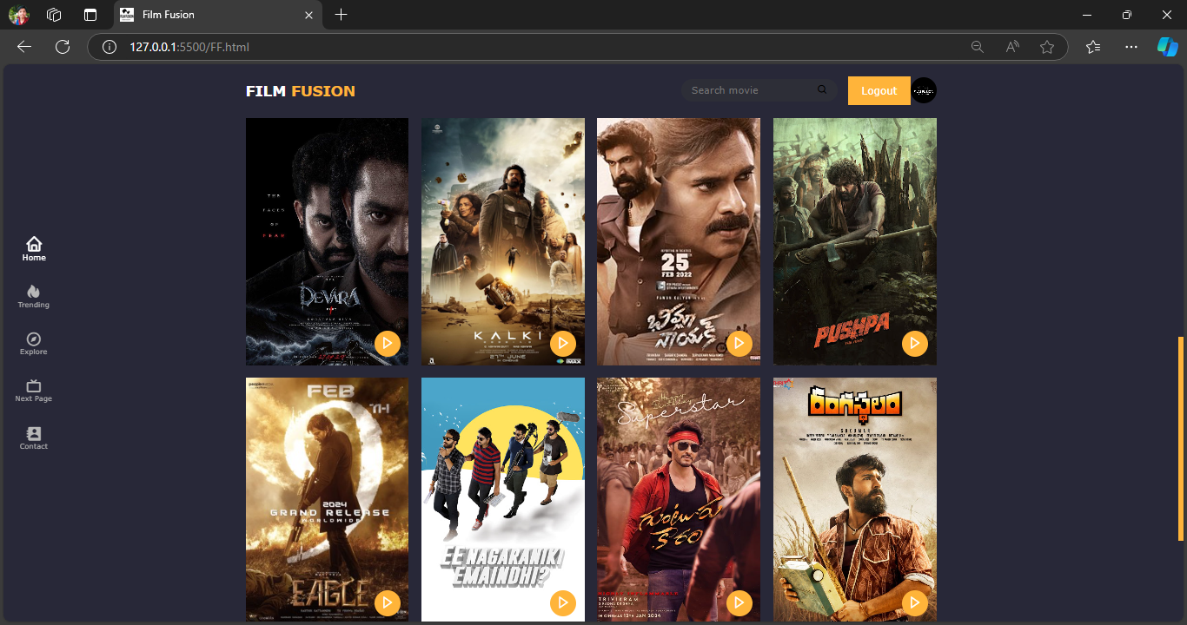

This page is the website home page, where you can find about all the movies in different languages offered in our platform and explore different movies, categorized on a language basis.

### Login page:

### .

### Registration Page:

If a user is new to the webpage, they can register here and get information about any new information that we post and receive newsletters via mail.

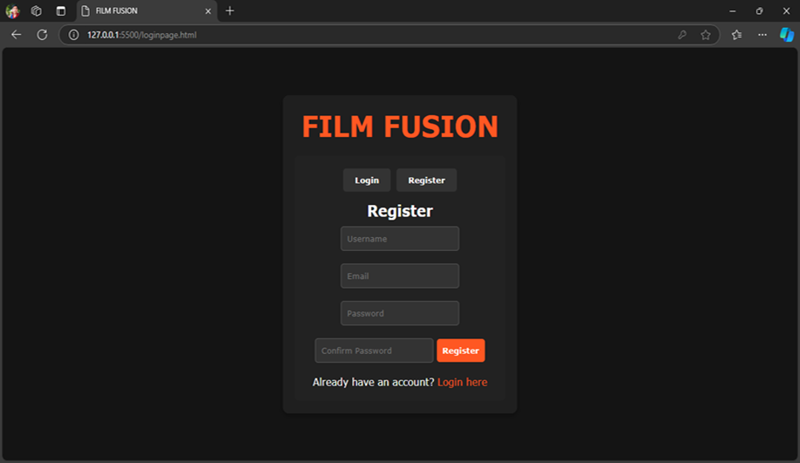

### Watch / Download movie:

Once the user chooses a movie of their choice, they can get an overview of the movie.

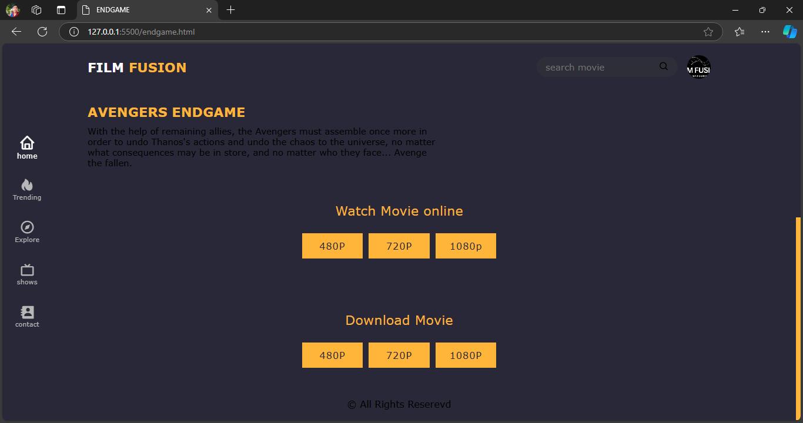

### Movie live page:

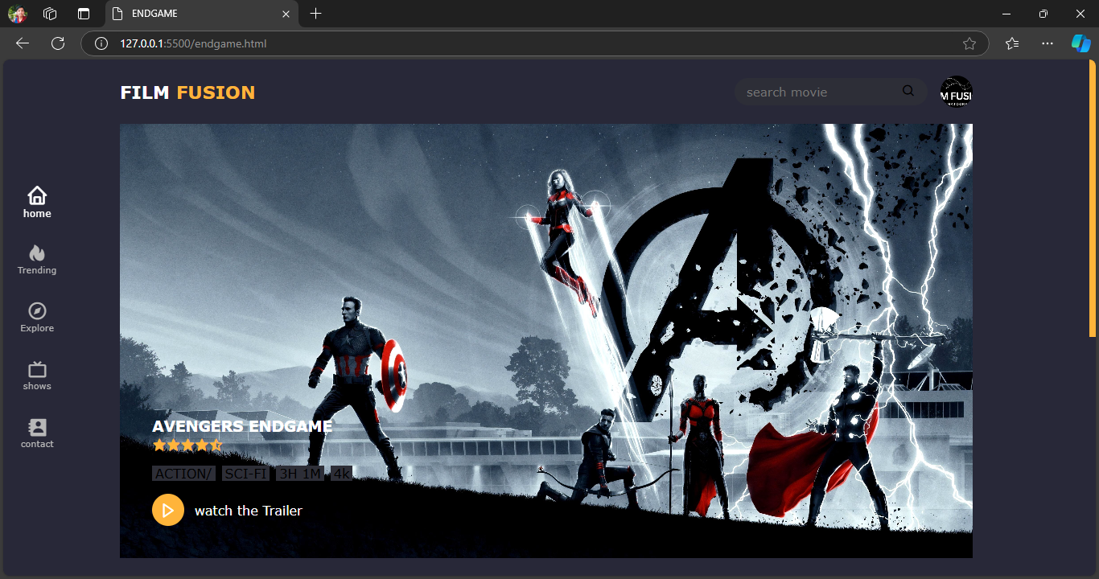

### vi. Feedback Page:

This is the webpage where a user can contact us , if they have any queries regarding anything in our website and leave a message for us.

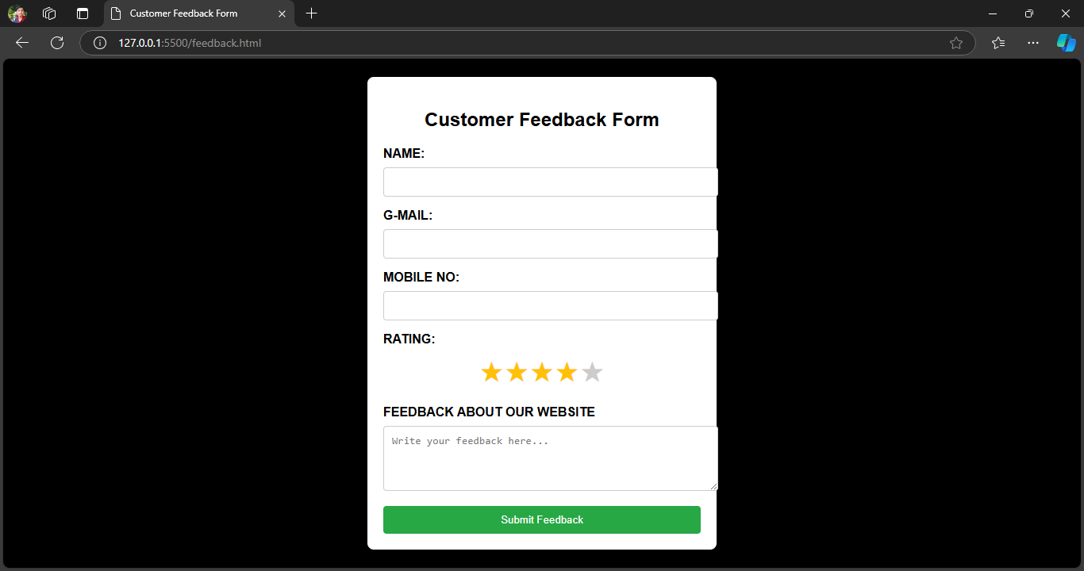

## CHAPTER-7 CONCLUSION AND FUTUREWORK

### Conclusion:

Film Fusion represents the future of digital entertainment, combining advanced web technologies and a user-centric approach to deliver high-quality, on-demand video streaming. The platform’s architecture is designed to offer a seamless and engaging experience, with adaptive streaming, personalized content recommendations, and robust security features that ensure privacy and content protection. With its intuitive design, comprehensive information, and interactive features, the website offers an engaging and user-friendly experience.

### Future Work:

This project offers several opportunities for future work and enhancements. Potential areas for future work include expanding the content by regularly updating and adding more features. The future of Film Fusion lies in continuing to innovate and evolve with new technologies, user demands, and market trends. By focusing on personalization, expanding the content library, integrating immersive experiences, and exploring new monetization strategies, Film Fusion can maintain its position as a leading OTT platform. Additionally, enhancing user engagement through social features and building a strong community will be critical to keeping the platform relevant and driving sustained growth in a competitive streaming landscape. Integrating multimedia elements like high-quality images, videos can enhance user engagement. Implementing user-generated content features such as reviews and ratings can faster a sense of community. Developing a mobile application version of the website can cater to users preferring mobile devices. Integration with social media platforms and multilingual support can increase reach and accessibility.